Slave Ads

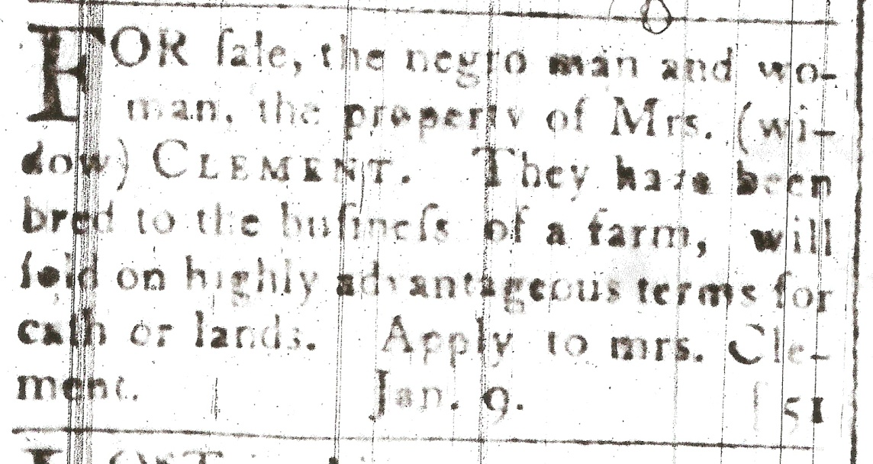

"For sale, the negro man and woman the property of Mrs. Widow Clement. They have been bred to the work of the farm; will be sold on highly advantageous terms for cash or lands. Apply to Mrs. Clement."

Niagara Herald, January 18, 1802

"For sale: a negro slave 18 years of age, stout and healthy: has had the smallpox and is capable of service either in the house or out of doors. The terms will be made easy to the purchaser, and cash or new lands received in payment. Enquire of the printer."

Niagara Herald January 2, 1802

"Wanted to purchase a negro girl from seven to twelve years of age of good disposition. For fuller particulars apply to the subscribers, W.& J. Cooke, West Niagara, Oct. 4th."

Gazette and Oracle October 11, 1797

"To be sold a healthy strong negro woman about 30 years of age; understands cooking, laundrying and the care of upoultry N.B.—She can dress ladies' hair. Enquire of the printers, York, Dec. 20, 1800."

Upper Canada Gazette, York December 20, 1800

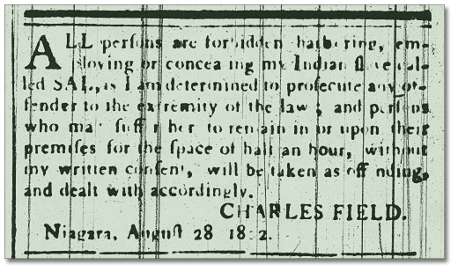
"All persons are forbidden harboring, employing or concealing my indian slave Sal. As I am determined to prosecute any offender, to the extremity of the law; and persons who may suffer her to remain in or upon their premises for the space of half an hour, without my written consent, will be taken as offending and dealt with accordingly.

CHARLES FIELD.
Niagara Herald, August 28, 1802

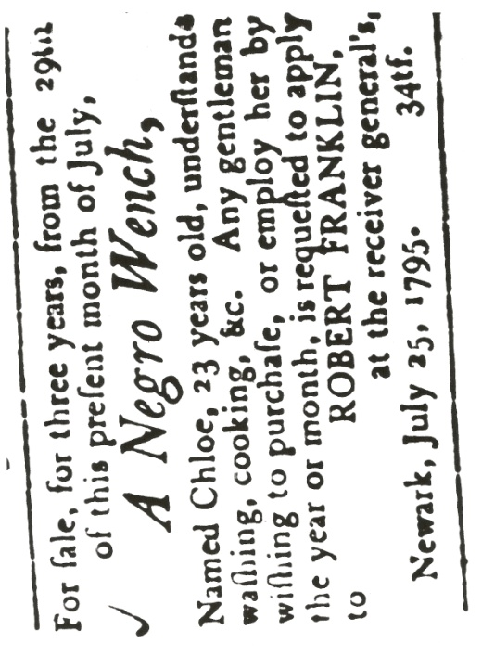
For Sale, for three years, from the 29th of this present month of July,
A Negro Wench, Named Chloe, 23 years old, understands washing Cooking &c. Any gentleman wishing to purchase, or employ her by the year or month, is requested to apply to ROBERT FRANKLIN, at the Receiver-General's.
Newark, July 25, 1795. 34tf.

Upper Canada Gazette, August 19th, 1795

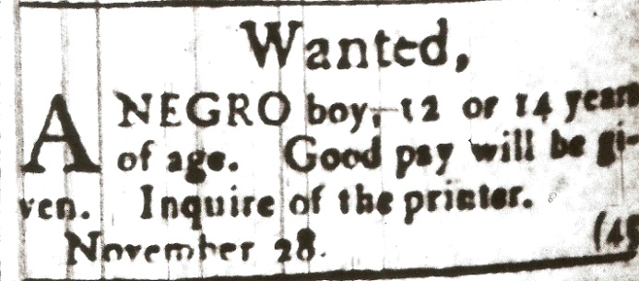

Wanted, A Negro boy, 12 or 14 years of age. Good pay will be given. Inquire of the printer.
Upper Canada Gazette November 28.

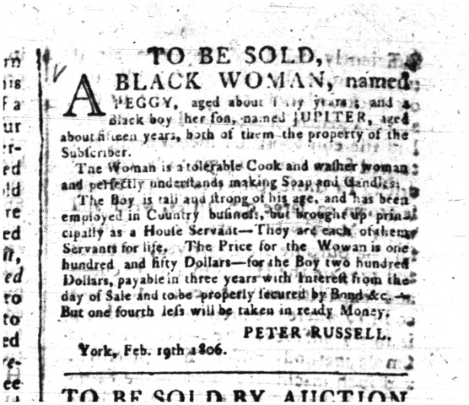

To be sold, A Black woman named Peggy, aged forty years, and a black boy, her son, named JUPITER, aged about fifteen years, both of them the property of the subscriber. The woman is a tolerable cook and washerwoman, and perfectly understands making soap and candles. The boy is tall and strong for his age, and has been employed in the country business, but brought up principally as a house servant. They are each of them servants for life. The price of the woman is one hundred and fifty dollars. For the boy two hundred dollars, payable in three years, with interest from the day of sale, and to be secured by bond &c. But one-fourth less will be taken for ready money.
PETER RUSSELL
York, Feb. 10th, 1806
Upper Canada Gazette, Feb. 10th, 1806

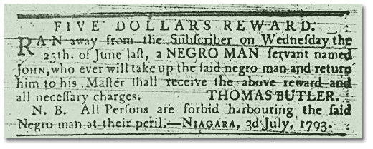
Upper Canada Gazette, July 3, 1793

"As Miles Prenties, tavern keeper in the Lower Town of Quebec, intends leaving the Province, he requests all persons who have any demands upon him to give in their accounts, and he also requests all persons who are indebted to him to make speedy payment, so as he may be better able to pay off his just debts.

"Mr. Prenties has to sell a negro woman aged 25 years with a mulatto male child 9 months old; she was formerly the property of General Murray; she can be well recommended for a good house servant, handles milk well and makes butter to perfection; Likewise a negro an aged 23 years, a very good house servant; understands waiting upon a gentleman and looks well in livery.

February 23, 1769, Quebec Gazette
Reposted four months later:

"To be sold at Public Vendue, on Friday, the 16th instant, a negro woman aged 25, with a mulatto male child 9 months old. She can be well recommended as a good house servant. Likewise a negro man, aged 23, a very good house servant and understands a good deal of cookery.”

June 15, 1769, Quebec Gazette

"To be sold, for no fault, the owner having no employ for him, a likely negro fellow about 22 or 23 years of age, understands cooking, waiting at table and household work, etc., etc. .He speaks both English and French. For further particulars enquire of the Printer."

Aug. 24, 1769, Quebec Gazette

Broke out of his Majesty’s goal in Quebec, on Saturday morning the 18th of February last, A NEGRO MAN SLAVE named JOE, born in Africa, twenty-six years of age, about five feet seven inches high, a little pitted with the small pox, has several scars on his legs, speaks English and French fluently, and is by trade a Press-Man; he had on him when he broke out a blue great coat, a red out-sid jacket, and round hat. He was seen some time ago in the parish of l’Ange Gardien below the falls of Montmorency. All persons are hereby forewarned from harbouring or aiding him to escape, as they may depend on being prosecuted to the utmost rigor of the Law; and whoever will give information where he is harboured, so at that he may be had again, shall receive THREE GUINEAS Reward from the Printer of the Quebec GAZETTE.

May 11, 1786, Quebec Gazette

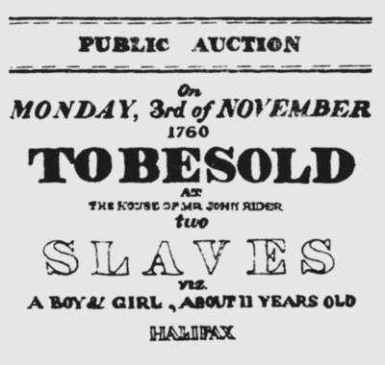

"To be sold at public auction, on Monday the 3rd of November, at the house of Mr. John Rider, two Slaves, viz.: a boy and girl, about eleven years old; likewise, a puncheon of choice old cherry brandy, with sundry other articles."

Halifax Gazette, November 1, 1760

FOURTEEN DOLLARS REWARD.
"Run away on Sunday night last from the subscriber, a negro man named Ishmael, about 36 years of age and nearly 5 feet 6 inches high ; of a remarkably downcast countenance and a black and copper coloured mixed complexion; his hair is short, strong, black and curly and his face much pitted with smallpox. He wants some of his upper fore teeth, likewise the first joint of the fore finger of his left hand. And besides on the middle of the right leg he has a fresh scar from a horse kick lately received and cured. Had on when he went off a round hat cocked up behind and a blue silk band, a red plush waistcoat, a pair of leggings and breeches in one, a pair of shoes and metal buckles.

"He came from Claverac near Albany in 1776 with his former master, C. Spencer, and speaks and read English tolerably well and understands a little Dutch and French. He passes himself, 'tis said, as a free negro, the more easily to effect his escape from the Province. Whoever will apprehend the said negro and deliver him to the subscriber, merchant, Montreal, shall receive the above reward and all reasonable charges from JOHN TURNER.

Montreal, March 1, 1784, Quebec Gazette

"Run away on the 11th September last, a negro woman, named Susannah, about 27 years of age, 5 feet 10 inches high (!) smooth faced, speaks French a little and English. Whoever apprehends and secures the said negro woman so that her master may have her again shall receive a reward of ten dollars by applying to Messrs. Dobie & Frobisher, merchants of Montreal or to the Printer here.

"N.B. Whoever harbors and conceals (?) said negro woman, shall be prosecuted to the utmost rigor of the law."
October 19, 1769, Quebec Gazette

RUN-AWAY
In a BIRCH CANOE, from the subscriber two
negro Men and one Wench, who have taken
sundry things with them. SAM, between a black
and dark mulatto 17 or 18 years old, middling
tall and slim, quick spoken, attempts to play the
VIOLIN, has a London brown coloured coat,
ticking trousers, and other clothes.

BELLER, a sister to SAM, between black and
mulatto, 16 years old, middling tall and slim, is
rawboned, has a scar between her eye and temple,
is slow in her speech, has a black covered hat
with white lining, and lived formerly with Judge
Peters at Saint John.

TONY SMITH, some call him JOE, a free
fellow, but hired for a time, he is tall and slim,
speaks broken, wears a blue or brown coat,
ticking trousers, and has other clothing with him.
Two of the above mentioned servants were raised
in the family. Any person apprehending them or
giving information to Mr. Ezra Scofield in King
Street, St. John, or the subscriber, shall have
one GUINEA for each, and if taken out of St.
John, reasonable charges paid - if taken out
of the province, it is requested that they may
be confined in jail until called for. All masters
of vessels and every other person is forewarned
not to carry any of these said negroes off or
from harbouring or concealing them, or they will
answer for it at their peril.
THOMAS LESTER
Waterborough, 19 June I787
The Royal Gazette, Saint John, N.B., July 17, 1787

